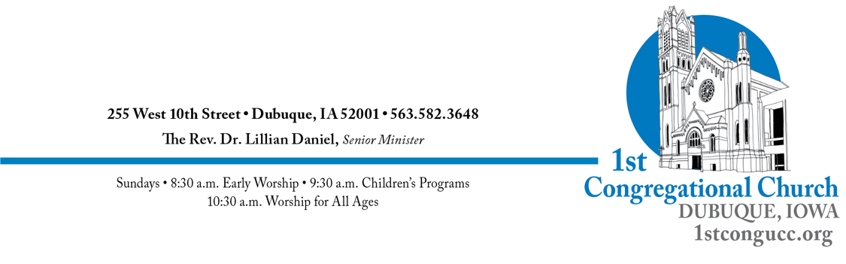
NEW MEMBER FORM
Bring your form to church or email it to office@1stcongucc.org
Name(s):

Address:

Home Phone: Cell Phone:

Email: Email: Preferred Method of Contact:

Birthdate: Wedding Anniversary Date:

Place(s) of Employment:

CHILDREN
Child’s Name Birthdate School/Work Baptism Year Confirmation Year

TELL US ABOUT YOURSELF!
In order to introduce you to our congregation, would you give us a few sentences about yourself that we could share? For example, where are you from, where do you work, what is your religious background? Your passions and hobbies? Family? How did you find our church and when did you start attending? Feel free to share anything that helps us connect with you so that we can welcome you warmly into our community.
Lastly, do you have any special interests in volunteering in church? Any other questions for us? We’re glad you are here!

